Sunday | Monday | Tuesday | Wednesday | Thursday | Friday | Saturday
1 | 2 | 3 | 4 | 5 | 6  Return Home Read Folder  Pizza Day  Library Day | 7
8 | 9 | 10 | 11  Library Day  Book Orders Due | 12  Lenten Liturgy | 13  Return Home Read Folder  -wear green for St. Patrick’s Day  -Apps’ Mill Class Trip | 14
15 | 16 | 17  St. Patrick’s Day | 18 | 19 | 20 | 21
22 | 23 | 24 | 25  STEM | 26  Pizza Day | 27  Return Home Read Folder  Library Day | 28
29 | 30 | 31  Happy Birthday Kollins and Ashlynn!
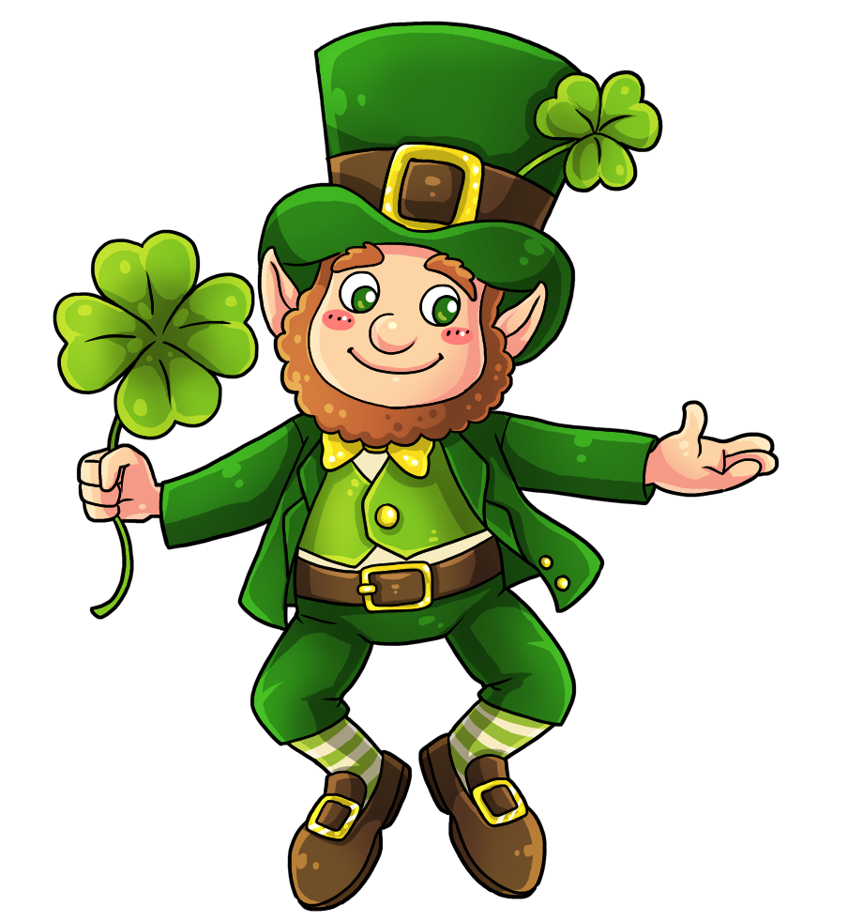
March Break
Miss Damaren’s March Class Calendar

