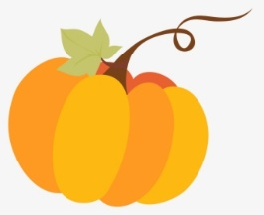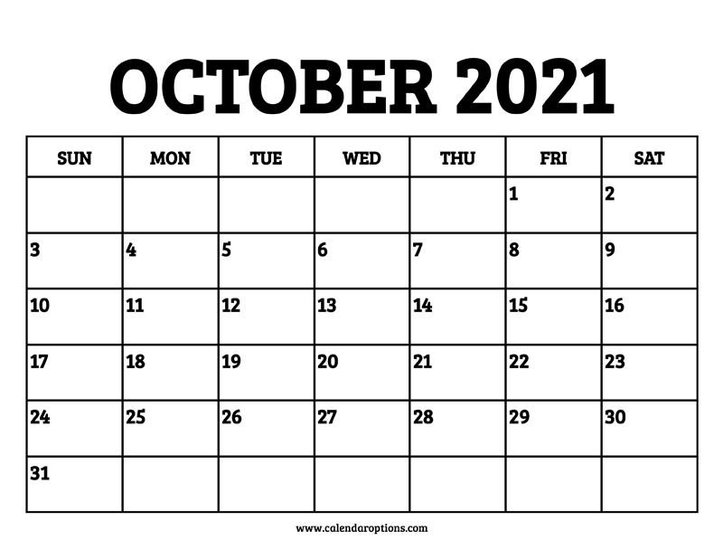

**P. A. Day**

**No school**

Letter Expert **Ww - Mikaella**

Halloween Party

Halloween

Letter Review

Letter Review

Letter Expert **Cc- Donnie**

Letter Expert **Bb - Jordynn**

Letter Expert **Rr - Kareem**

Letter Expert **Ii - Mine**

Letter Expert **Hh - Gabriel**

Letter Expert **Ee - Ezmee**

Letter Expert **Kk - Kaisley**

Letter Expert **Ss - Rosalee**

Letter Expert **Cc - Donnie**

Letter Expert **Pp - Ava**

Letter Review

Letter Review

Thanksgiving Day

Letter Expert **Tt - Wyatt**

Letter Expert **Aa - Spencer**